Parish of St Barnabas, Swanmore

Notice of Meeting of Parishioners

The Meeting of Parishioners will be held
via zoom
on
Wednesday 28th October 2020 at 7pm

For the election of Churchwardens
Meeting ID: 896 1308 5287
Passcode: 067339

Signed: The Revd Claire Towns 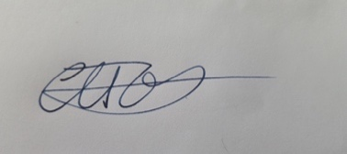 Vicar

