Sunday October 4th 2020
10am

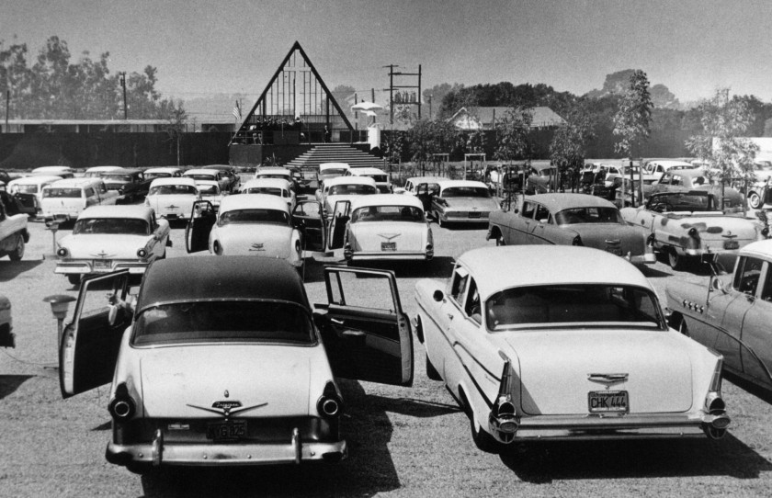

Drive-in
Harvest Festival
Non-perishable goods are being collected for local foodbanks and money donations to be split 3-ways between Water Aid, Christians Against Poverty and Emmaus, Winchester

Keeping Covid-Safe during this service:

- We ask you to please arrive between 0940 and 0955 and to park where the stewards guide you to.
- We ask you to please stay inside your cars for the duration of the service, unless invited to step outside.
- Car windows and doors on both sides may be opened for air.
- The Village Hall’s toilets are not available for use.
- Orders of service will be available for those who do not have the means to print their copy or to view the service on a device. Stewards, handing out orders of service will wear gloves and/or sanitise hands frequently.
- At the end of the service please stay in your car and wait for the stewards to advise you when it is safe to drive away.
- Enjoy!

Words of welcome from Revd. Claire

The prayer of the Day

Creator God,
you made the goodness of the land,
the riches of the sea
and the rhythm of the seasons;
as we thank you for the harvest,
may we cherish and respect
this planet and its peoples,
through Jesus Christ our Lord. Amen

Hymn 1: We plough the fields and scatter

We plough the fields and scatter
the good seed on the land,
but it is fed and watered
by God’s almighty hand:
he sends the snow in winter,
the warmth to swell the grain,
the breezes and the sunshine,
and soft refreshing rain.
All good gifts around us
are sent from heaven above;
then thank the Lord, O thank the Lord,
for all his love.
He only is the maker
of all things near and far;
he paints the wayside flower,
he lights the evening star;
he fills the earth with beauty,
by him the birds are fed;
much more to us, his children,
he gives our daily bread.
Chorus

We thank thee, then, O Father,
for all things bright and good;
the seedtime and the harvest,
our life, our health, our food.
Accept the gifts we offer
for all thy love imparts,
and what thou most desirest,
our humble, thankful hearts.
Chorus

Reading 1: 2 Corinthians 9:6-end
The point is this: the one who sows sparingly will also reap sparingly, and the one who sows bountifully will also reap bountifully. Each of you must give as you have made up your mind, not reluctantly or under compulsion, for God loves a cheerful giver.
And God is able to provide you with every blessing in abundance, so that by always having enough of everything, you may share abundantly in every good work. As it is written,
‘He scatters abroad, he gives to the poor;
his righteousness endures for ever.’
He who supplies seed to the sower and bread for food will supply and multiply your seed for sowing and increase the harvest of your righteousness. You will be enriched in every way for your great generosity, which will produce thanksgiving to God through us; for the rendering of this ministry not only supplies the needs of the saints but also overflows with many thanksgivings to God.
Through the testing of this ministry you glorify God by your obedience to the confession of the gospel of Christ and by the generosity of your sharing with them and with all others, while they long for you and pray for you because of the surpassing grace of God that he has given you. Thanks be to God for his indescribable gift!

This is the Word of the Lord
Thanks be to God

Hymn: Magic Penny

Love is something if you give it away,
give it away, give it away.
Love is something if you give it away,
you end up having more.

It's just like a magic penny,
hold it tight and you won't have any.
Lend it, spend it, and you'll have so many
they'll roll all over the floor.

Love is something…

Money doesn't have magic in it,
things we buy might break in a minute.
Love's a circle, so let's begin it
and bring it to every door.

Love is something…

So let's go dancing till the break of day,
and if there's a piper, we can pay.
For love is something if you give it away,
you end up having more.

Love is something…

Reading 2: Luke 12:16-30
Then Jesus told them a parable: ‘The land of a rich man produced abundantly. And he thought to himself, “What should I do, for I have no place to store my crops?” Then he said, “I will do this: I will pull down my barns and build larger ones, and there I will store all my grain and my goods. And I will say to my soul, Soul, you have ample goods laid up for many years; relax, eat, drink, be merry.”
But God said to him, “You fool! This very night your life is being demanded of you. And the things you have prepared, whose will they be?” So it is with those who store up treasures for themselves but are not rich towards God.’
He said to his disciples, ‘Therefore I tell you, do not worry about your life, what you will eat, or about your body, what you will wear. For life is more than food, and the body more than clothing. Consider the ravens: they neither sow nor reap, they have neither storehouse nor barn, and yet God feeds them. Of how much more value are you than the birds! And can any of you by worrying add a single hour to your span of life?
If then you are not able to do so small a thing as that, why do you worry about the rest? Consider the lilies, how they grow: they neither toil nor spin; yet I tell you, even Solomon in all his glory was not clothed like one of these. But if God so clothes the grass of the field, which is alive today and tomorrow is thrown into the oven, how much more will he clothe you—you of little faith! And do not keep striving for what you are to eat and what you are to drink, and do not keep worrying. For it is the nations of the world that strive after all these things, and your Father knows that you need them.

This is the Word of the Lord
Thanks be to God

Hymn: Let us with a gladsome mind

Let us, with a gladsome mind,
praise the Lord, for he is kind:
for his mercies aye endure,
ever faithful, ever sure.

Let us blaze his name abroad,
for of gods he is the God:
for his mercies aye endure,
ever faithful, ever sure.

He with all commanding might,
filled the new-made world with light:
for his mercies aye endure,
ever faithful, ever sure.

He the golden-tressèd sun
caused all day his course to run:
for his mercies aye endure,
ever faithful, ever sure.

And the moon to shine at night,
‘mid her starry sisters bright:
for his mercies aye endure,
ever faithful, ever sure.

All things living he doth feed,
his full hand supplies their need:
for his mercies aye endure,
ever faithful, ever sure.

Let us, with a gladsome mind,
praise the Lord, for he is kind:
for his mercies aye endure,
ever faithful, ever sure.

Reflecting on the Bible Reading/s: by Revd. Claire

Hymn: All creatures of our God and King

During the singing of this hymn you are invited to please bring forward your harvest offerings. Please follow the guidance of the stewards and maintain social distancing at all times. Please do not sing when outside of your car. Thank you.

All creatures of our God and King,
lift up your voice and with us sing
alleluia, alleluia!
Thou burning sun with golden beam,
thou silver moon with softer gleam:
O praise him, O praise him,
alleluia, alleluia, alleluia!

Thou rushing wind that art so strong,
ye clouds that sail in heav'n along,
O praise him, alleluia!
Thou rising morn, in praise rejoice,
ye lights of evening, find a voice:

O praise him…

Thou flowing water, pure and clear,
make music for thy Lord to hear,
alleluia, alleluia!
Thou fire so masterful and bright,
that givest us both warmth and light:

O praise him…

Dear mother earth, who day by day
unfoldest blessings on our way,
O praise him, alleluia!
The flow’rs and fruits that in thee grow,
let them his glory also show:

O praise him…

All you with mercy in your heart,
forgiving others, take your part,
O sing ye, alleluia!
Ye who long pain and sorrow bear,
praise God and on him cast your care:

O praise him…

Let all things their Creator bless,
and worship him in humbleness,
O praise him, alleluia!
Praise, praise the Father, praise the Son,
and praise the Spirit, three in one:
O praise him…

Prayer of offering

Thank you, loving God, for your goodness that blesses us, and the earth. You are generous.
Thank you, God.

Thank you, loving God, for the people who grew or made this food and those who will share in it. You are generous.
Thank you, God.

Thank you, loving God, for our village, this church and for your faithful love over many generations. You are generous.
Thank you, God.

Father God, all that we have comes from you. May what we have offered and returned to you today be a blessing to many and be used to help bring about your good purposes.
In the name of Christ and through the power of the Spirit. Amen.
Hymn: For the fruits of his creation

For the fruits of his creation
thanks be to God;
for his gifts to ev’ry nation
thanks be to God;
for the ploughing, sowing, reaping,
silent growth while we are sleeping,
future needs in earth’s safe keeping,
thanks be to God.

In the just reward of labour,
God’s will is done;
in the help we give our neighbour,
God’s will is done;
in our worldwide task of caring
for the hungry and despairing,
in the harvests we are sharing,
God’s will is done.

For the harvests of the Spirit,
thanks be to God;
for the good we all inherit,
thanks be to God;
for the wonders that astound us,
for the truths that still confound us,
most of all, that love has found us,
thanks be to God.

The peace
You may get out of your cars for the peace but please refrain from moving about

The peace of the Lord by always with you
And also with you

Prayers

The Lord’s Prayer – as adapted by The Revd. Dr. Sam Wells, Vicar of St. Martin in-the-Fields, London

Look on us with kindness and mercy.
hallowed be your name,

Give us a true perspective of what matters and what doesn’t
your kingdom come,

Recast the world in your image
your will be done, on earth as in heaven.

Give me the humility to live in your story not mine.
Give us today our daily bread.
You are enough for me.
Forgive us our sins as we forgive those who sin against us.

Heal my past from hurt
Lead us not into temptation
but deliver us from evil.

Free my future from fear.
For the kingdom, the power, and the glory are yours now and for ever.

Show me how to live your forever in my today
Amen.

Hymn: Beauty for brokenness

Beauty for brokenness, hope for despair,
Lord in the suffering, this is our prayer:
bread for the children, justice, joy, peace;
sunrise to sunset, your kingdom increase.

Shelter for fragile lives, cures for their ills,
work for the craftsmen, trade for their skills;
land for the dispossessed, rights for the weak,
voices to plead the cause of those who can't speak.

God of the poor, friend of the weak
give us compassion we pray!
Melt our cold hearts, let tears fall like rain,
come, change our love from a spark to a flame.

Refuge from cruel wars, havens from fear;
cities for sanctuary, freedoms to share.
Peace to the killing-fields, scorched earth to green,
Christ for the bitterness, his cross for the pain.

God of the poor…

Rest for the ravaged earth, oceans and streams
plundered and poisoned, our future, our dreams.
Lord, end our madness, carelessness, greed;
make us content with the things that we need.

God of the poor…

Lighten our darkness, breathe on this flame
until your justice burns brightly again,
until the nations learn of your ways,
seek your salvation and bring you their praise

God of the poor…

Final Prayers

We have celebrated harvest, brought our gifts,
sung our hymns and remembered our God.

As we go out into our Covid-suffering world, to our homes, our places of work and to our schools,
may God help us to live our lives as people of the harvest,
to share and to give, to bless and to love,
through Jesus, our friend and Saviour. Amen.
Blessing

The Lord bless you and watch over you,
the Lord make his face shine upon you
and be gracious to you,
the Lord look kindly on you and give you peace;
and the blessing … Amen

Go in peace to love and serve the Lord
In the name of Christ. Amen.

