Hymns for Sunday 6th September 2020

Hymn for the preparation of the altar

O God you search me and you know me

O God, you search me and you know me.
All my thoughts lie open to your gaze.
When I walk or lie down, you are before me,
ever the maker and keeper of my days.

You know my resting and my rising.
You discern my purpose from afar,
and with love everlasting you besiege me:
In ev'ry moment of life or death, you are.

Before a word is on my tongue, Lord,
You have known its meaning through and through.
You are with me beyond my understanding:
God of my present, my past and future too.

Although your Spirit is upon me,
still I search for shelter from your light.
There is nowhere on earth I can escape you:
even the darkness is radiant in your sight.

For you created me and shaped me,
Gave me life within my mother's womb.
For the wonder of who I am, I praise you:
Safe in your hands, all creation is made new.

O God, you search me and you know me.
All my thoughts lie open to your gaze.
When I walk or lie down, you are before me,
ever the maker and keeper of my days.

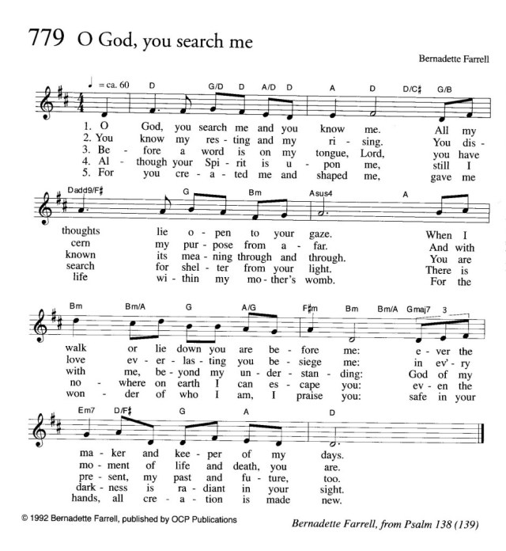

Hymn after communion

Take my life and let it be

Take my life and let it be
consecrated, Lord, to thee;
take my moments and my days,
let them flow in ceaseless praise.
Take my hands, and let them move
at the impulse of thy love;
Take my feet, and let them be
swift and beautiful for thee.

Take my voice, and let me sing
always, only for my King;
take my lips, and let them be
filled with messages from thee.
Take my silver and my gold:
not a might would I withhold;
take my intellect and use
ev’ry power as thou shalt choose.

Take my will and make it thine;
it shall be no longer mine;
take my heart, it is thine own;
it shall be thy royal throne.
Take my love, my Lord, I pour
at thy feet its treasure store;
take myself and I will be
ever, only, all for thee.

